**Trending Effects Report**

My first assumption from a naive perspective one would assume that the trending of unnatural deaths should match the trending of population growth. I.e. the death rates should directly tie into the population growth rate.

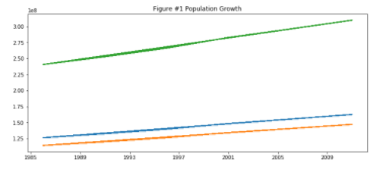

There are so many other factors that come into play when we are looking at the death rates . Geo-political, environmental, Economical, etc. With the data we believe one will be able to tie any anomalies in the growth. Taking the total death trending as an international total one can see the trending is more erratic than the population trending.

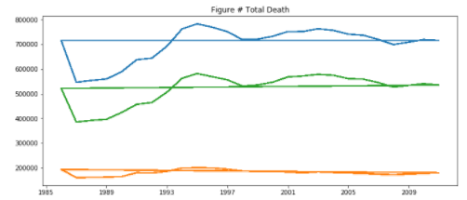

When splitting the unnatural deaths by type :

*Transportation incidents when taken as an aggregate has an overall downward slope showing that even though the population is trending upwards. This is contrary to our initial suggestion of naive correlation.*

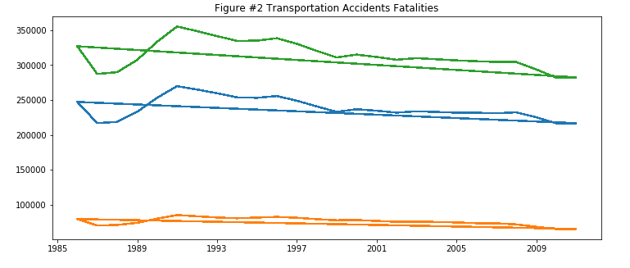

*Incidents involving falls have an upwards slope but have more volatility than that of the population growth. There appears to be an increase*

